1. Query for super classes of apple

SELECT ?apple ?y WHERE {

?apple rdfs:subClassOf ?y

}

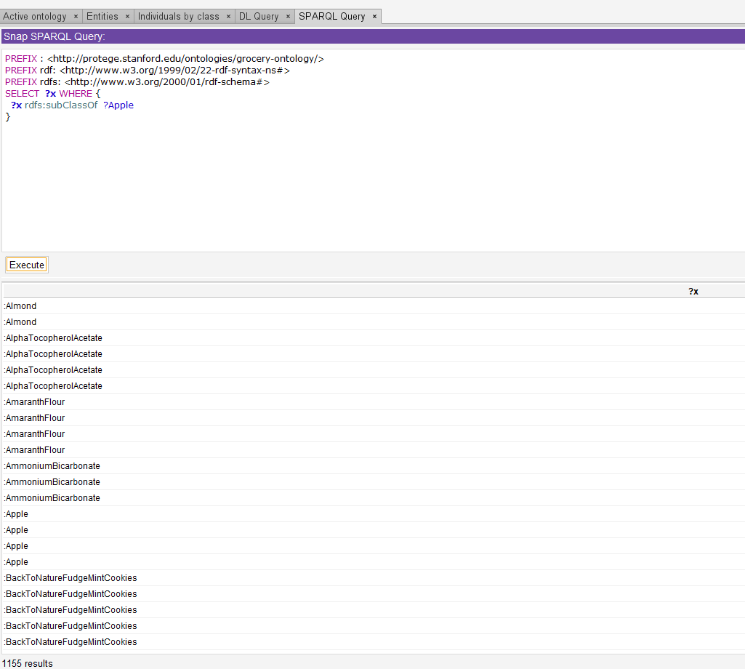

1. **Query for sub classes of whole meal flour**

SELECT ?x WHERE {

?x rdfs:subClassOf :WholemealFlour }

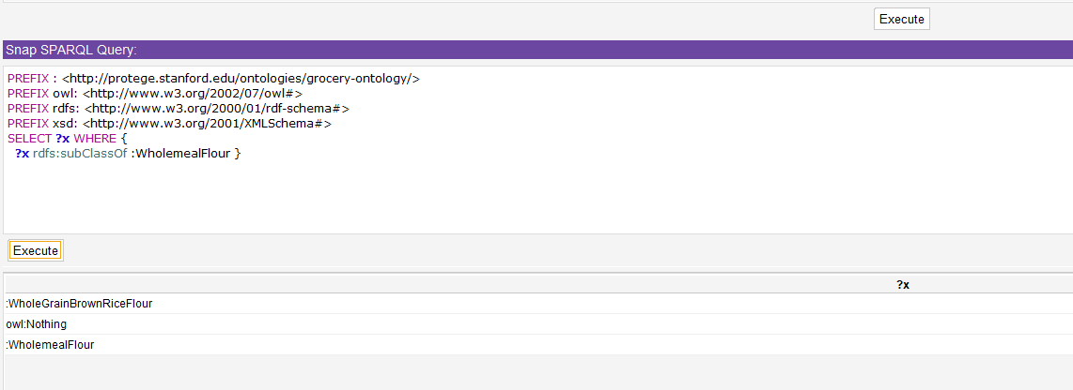

1. **Query for the label of super classes of cashew**

PREFIX : <http://protege.stanford.edu/ontologies/grocery-ontology/>

PREFIX owl: <http://www.w3.org/2002/07/owl#>

PREFIX rdfs: <http://www.w3.org/2000/01/rdf-schema#>

PREFIX xsd: <http://www.w3.org/2001/XMLSchema#>

SELECT **?x** **?y** WHERE {

**?x** rdfs:subClassOf :Cashew.

**?x** rdfs:label **?y**

}

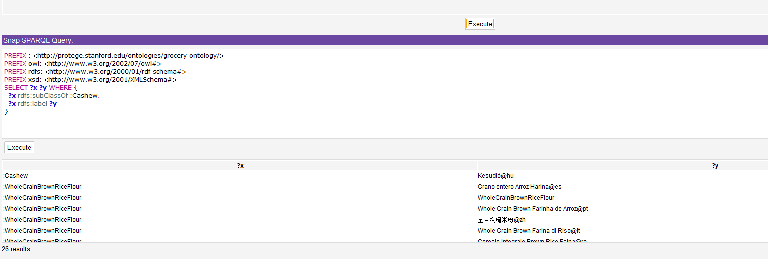

**4 Order the returned result set from (3) by label in ascending order**

PREFIX : <http://protege.stanford.edu/ontologies/grocery-ontology/>

PREFIX owl: <http://www.w3.org/2002/07/owl#>

PREFIX rdfs: <http://www.w3.org/2000/01/rdf-schema#>

PREFIX xsd: <http://www.w3.org/2001/XMLSchema#>

SELECT **?x** **?y** WHERE {

**?x** rdfs:subClassOf :Cashew.

**?x** rdfs:label **?y**

}

ORDER BY ASC(**?y**)

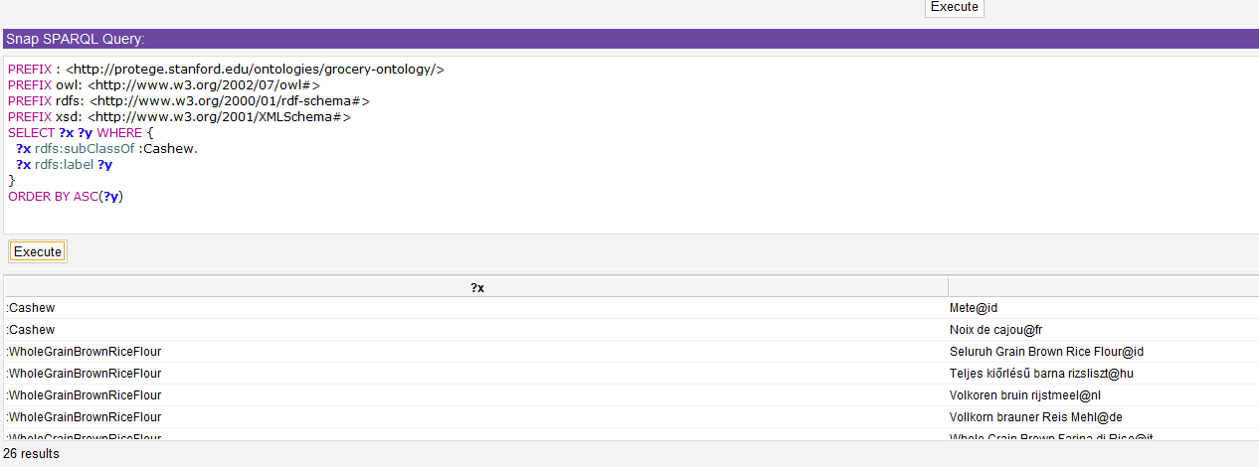

**5**

PREFIX : <http://protege.stanford.edu/ontologies/grocery-ontology/>

PREFIX owl: <http://www.w3.org/2002/07/owl#>

PREFIX rdfs: <http://www.w3.org/2000/01/rdf-schema#>

PREFIX xsd: <http://www.w3.org/2001/XMLSchema#>

SELECT **?x** WHERE {

**?x** rdf:type :Continent.

}

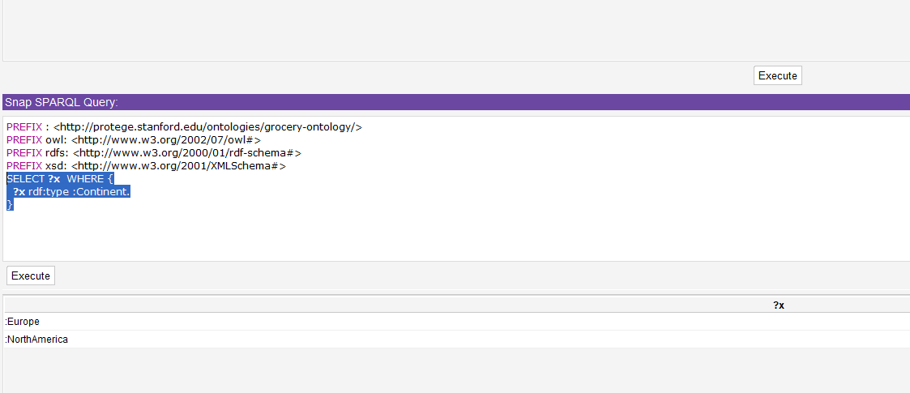

**6**

PREFIX : <http://protege.stanford.edu/ontologies/grocery-ontology/>

PREFIX owl: <http://www.w3.org/2002/07/owl#>

PREFIX rdfs: <http://www.w3.org/2000/01/rdf-schema#>

PREFIX xsd: <http://www.w3.org/2001/XMLSchema#>

SELECT **?continent** **?country** WHERE {

**?continent** :isLocatedIn **?country**

}

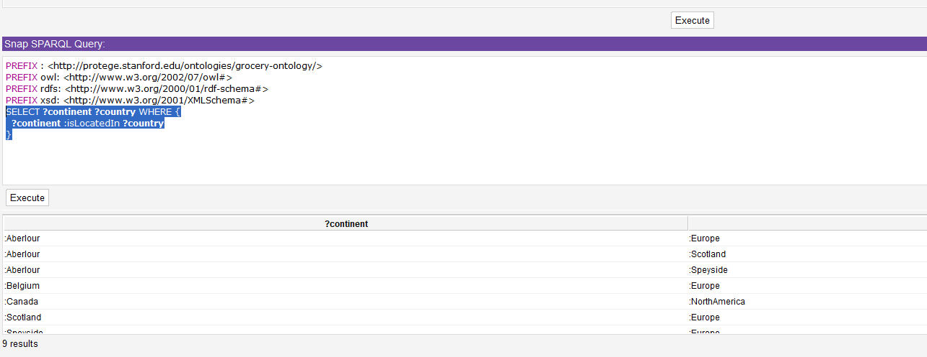

**7**

PREFIX : <http://protege.stanford.edu/ontologies/grocery-ontology/>

PREFIX owl: <http://www.w3.org/2002/07/owl#>

PREFIX rdfs: <http://www.w3.org/2000/01/rdf-schema#>

PREFIX xsd: <http://www.w3.org/2001/XMLSchema#>

SELECT **?x** WHERE {

**?x** :isLocatedIn ?NorthAmerica

}

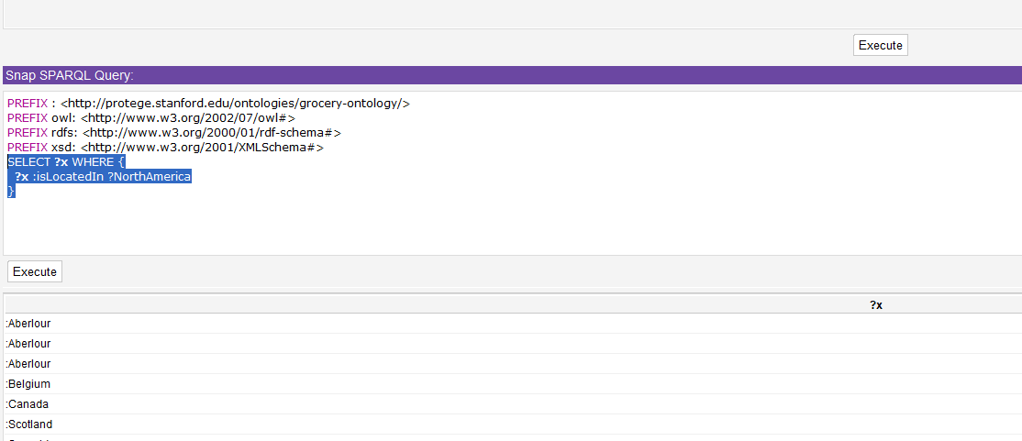

**8**

PREFIX : <http://protege.stanford.edu/ontologies/grocery-ontology/>

PREFIX owl: <http://www.w3.org/2002/07/owl#>

PREFIX rdfs: <http://www.w3.org/2000/01/rdf-schema#>

PREFIX xsd: <http://www.w3.org/2001/XMLSchema#>

SELECT **?x** WHERE {

**?x** rdfs:subClassOf ?y

}

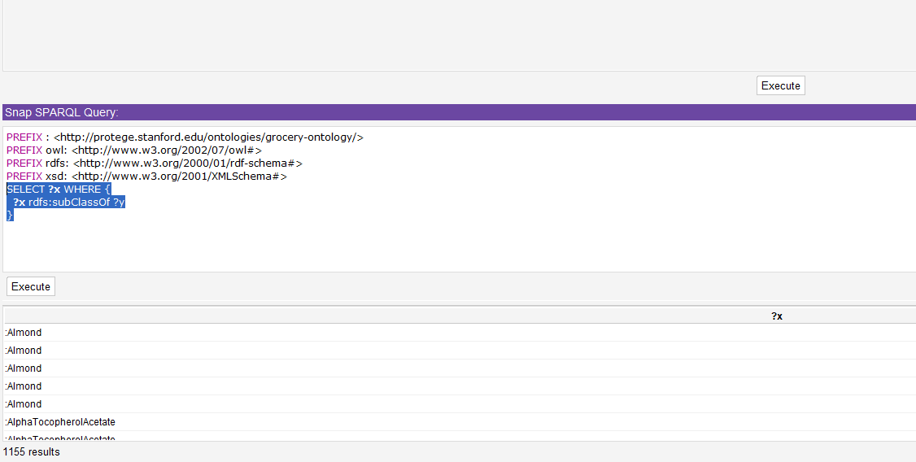

**9**

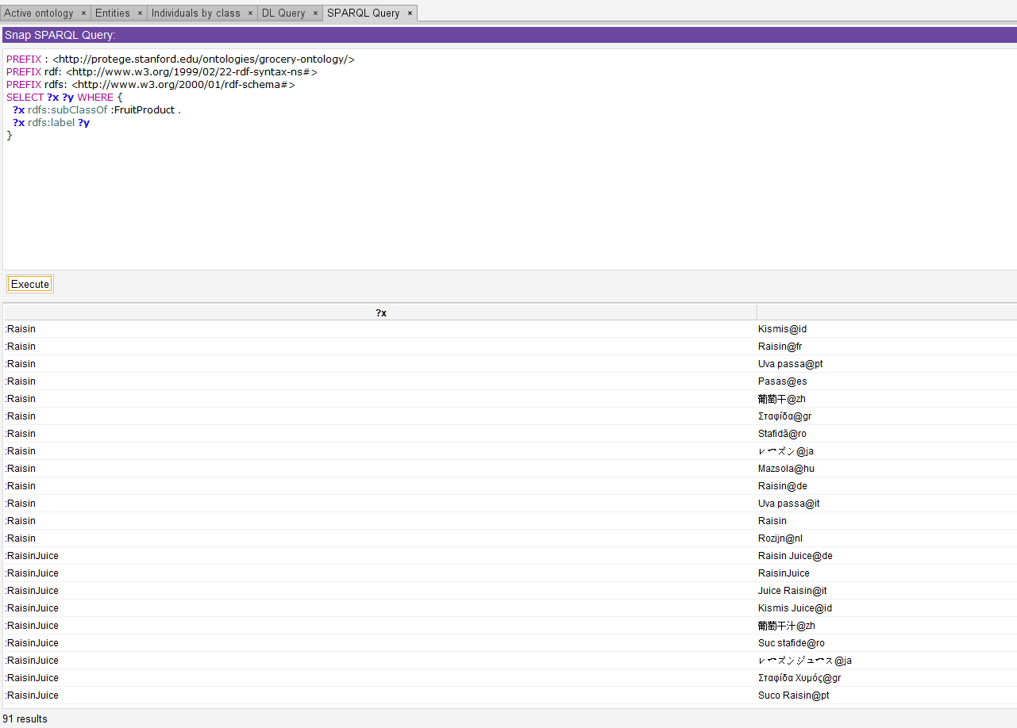

**10**

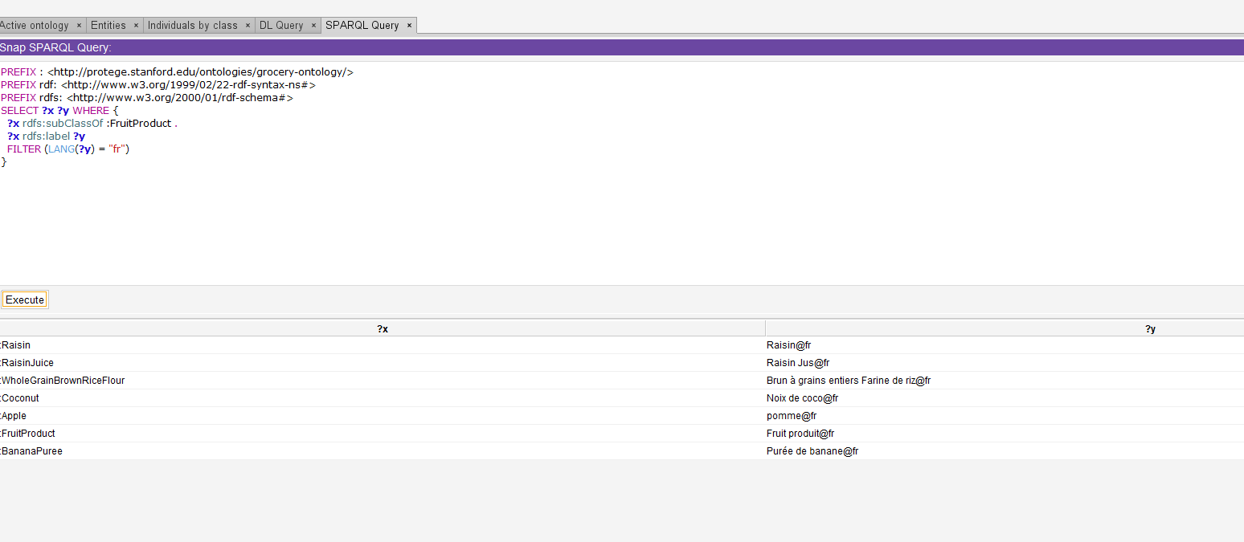

**11**

PREFIX : <http://protege.stanford.edu/ontologies/grocery-ontology/>

PREFIX owl: <http://www.w3.org/2002/07/owl#>

PREFIX rdfs: <http://www.w3.org/2000/01/rdf-schema#>

PREFIX xsd: <http://www.w3.org/2001/XMLSchema#>

SELECT **?x** WHERE {

**?x** :isSoldByStore :SafewayMenloPark

}

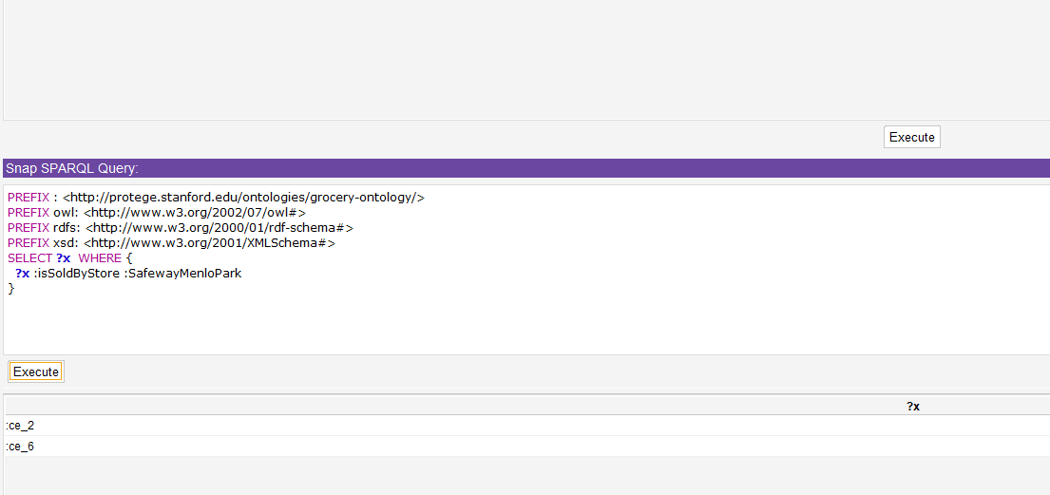

**12**

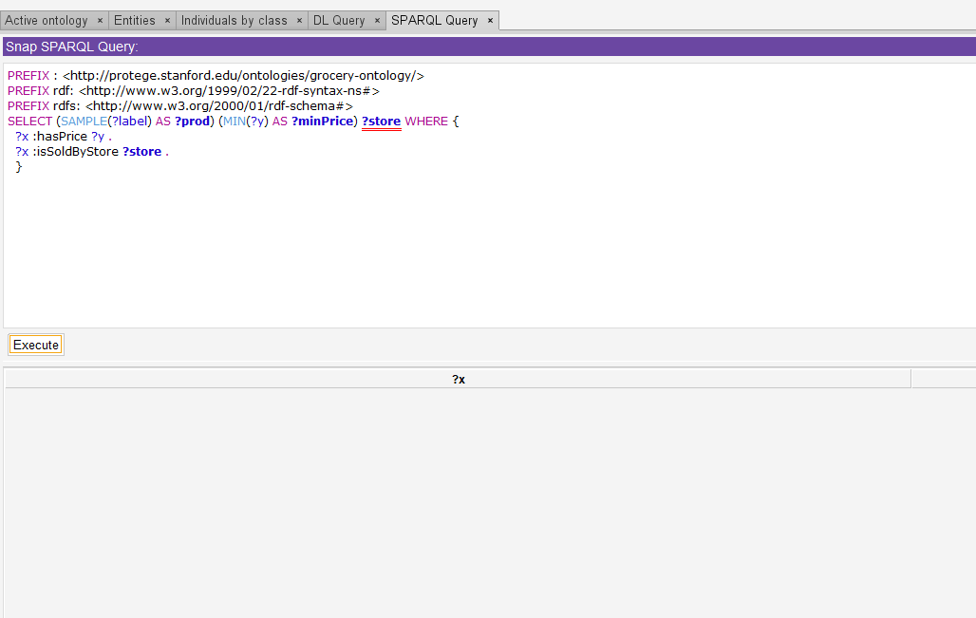

**13**

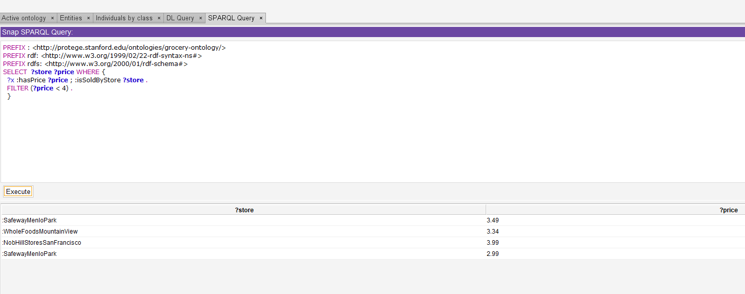

**14**

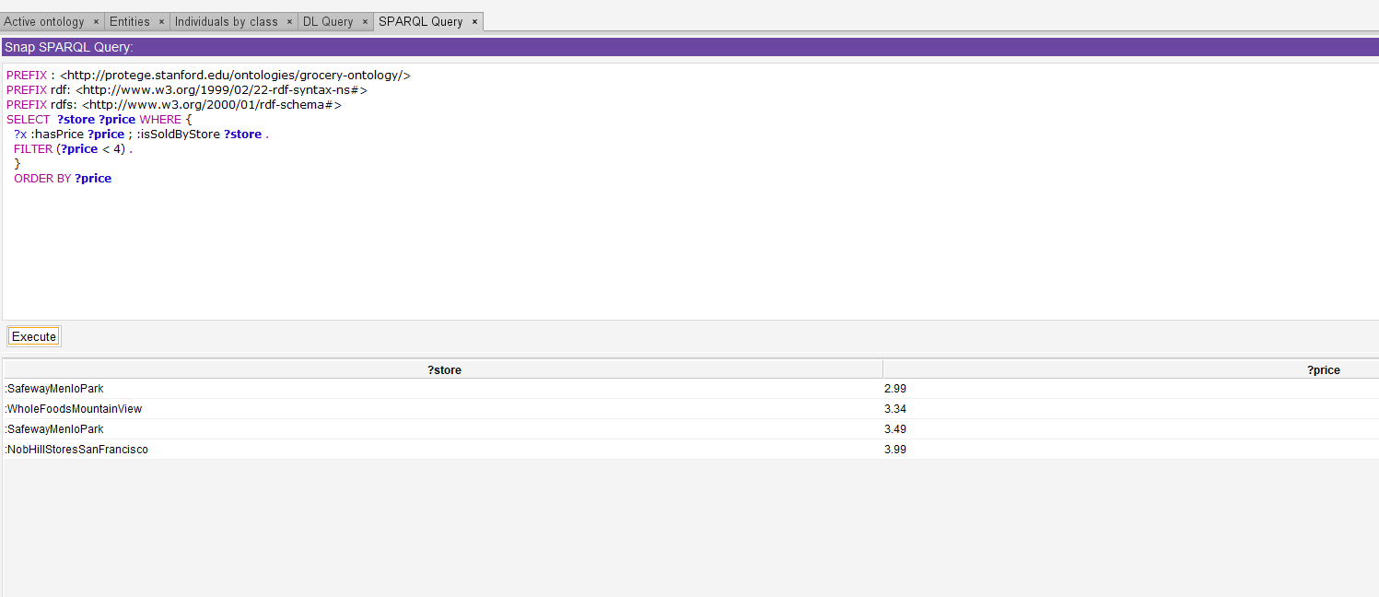

**15**

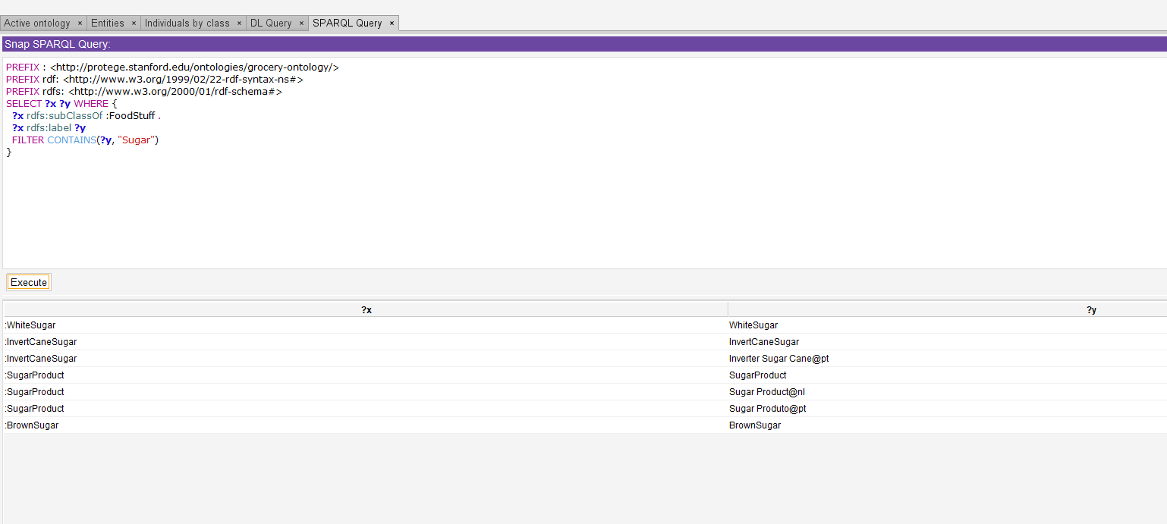

**16**

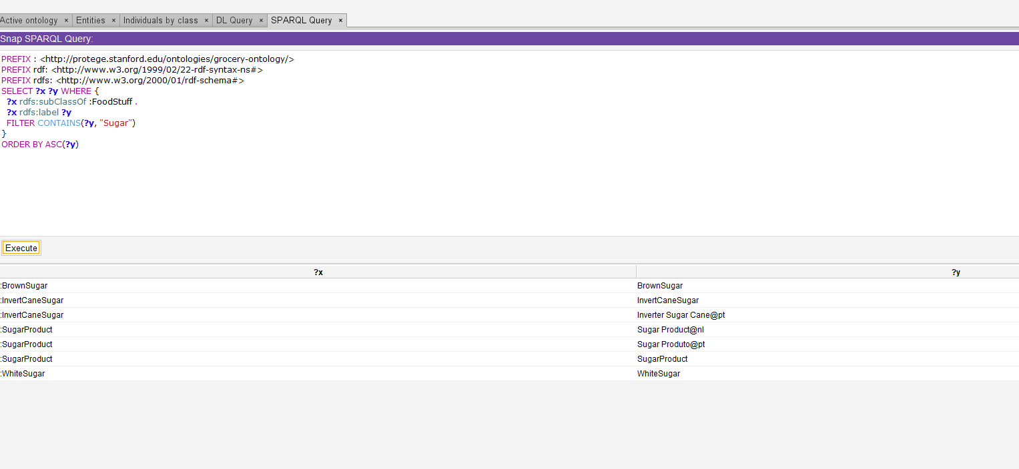

**17**

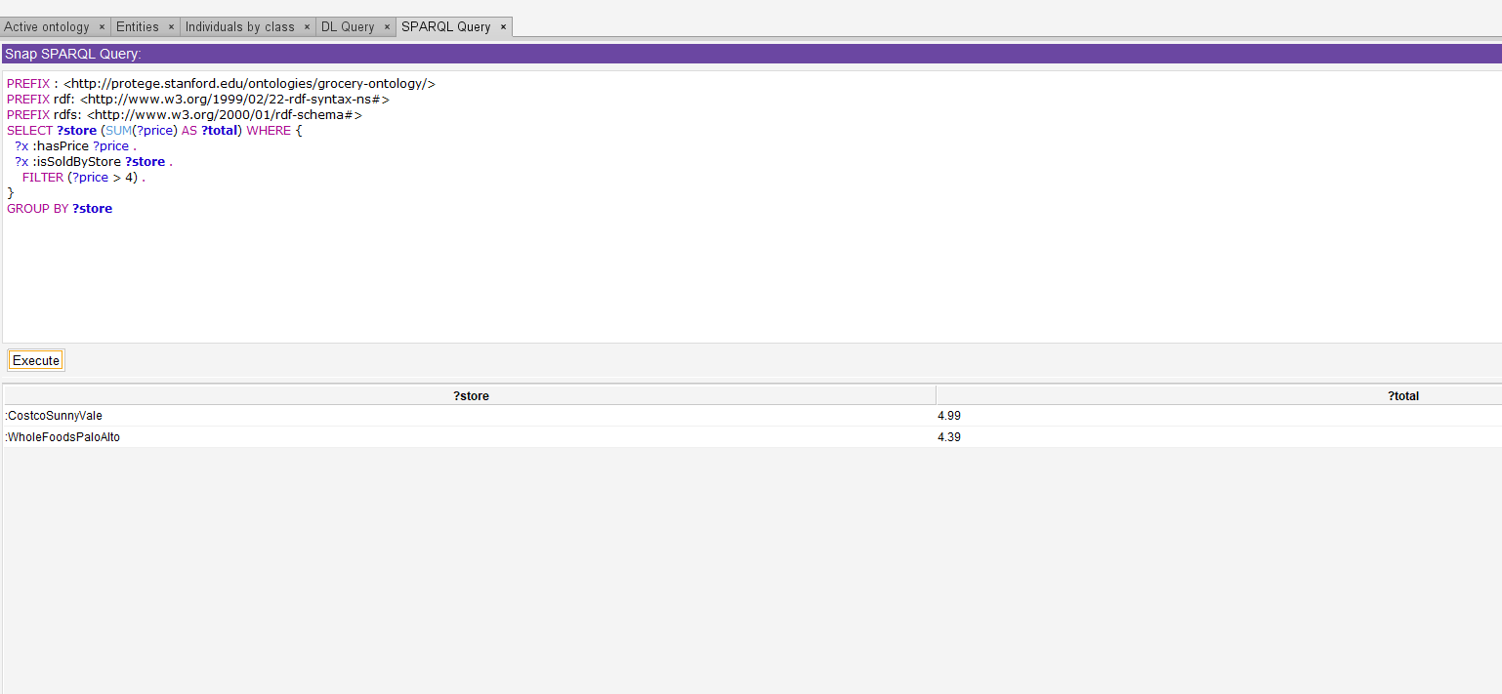

**18**

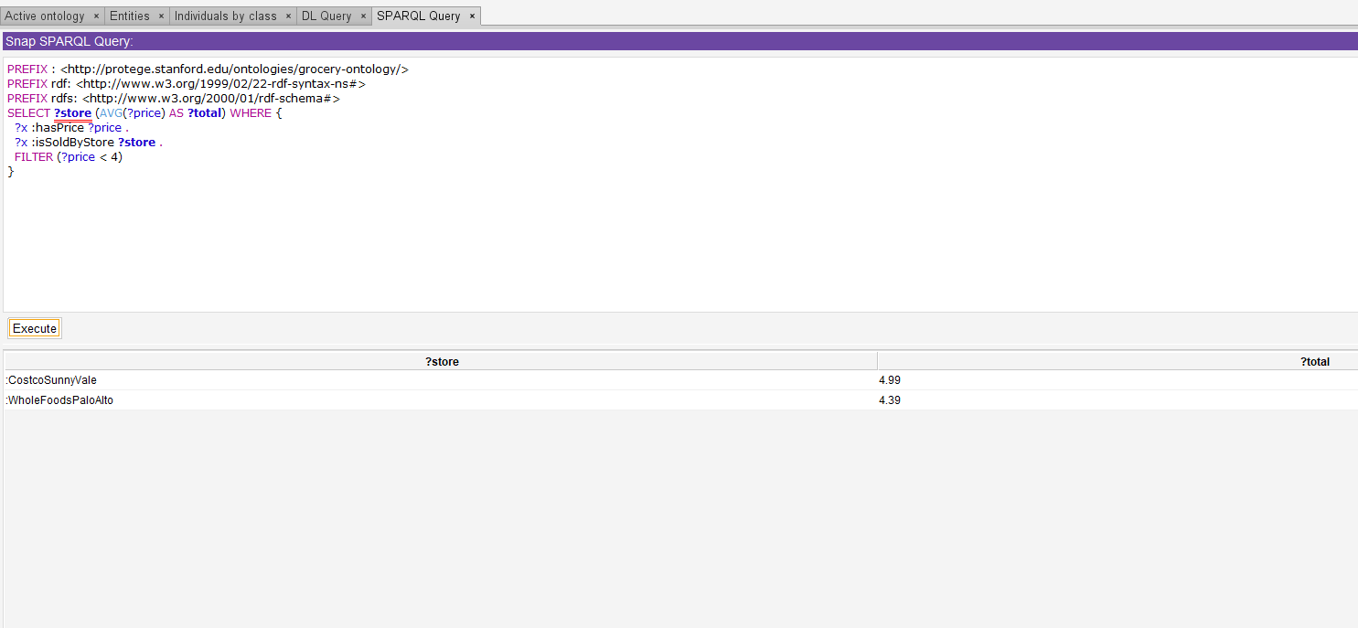

**19**

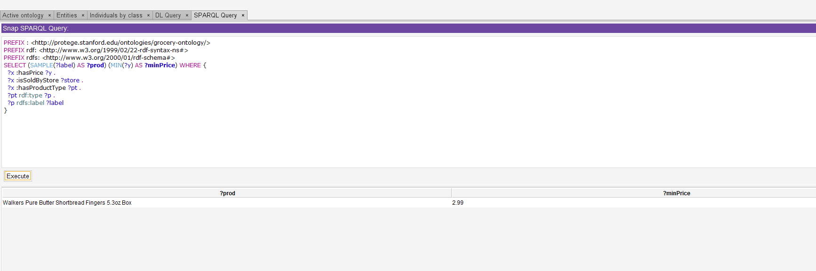

**20**

